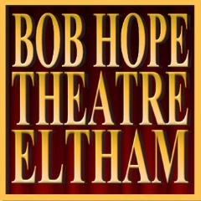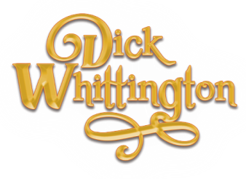
BOB HOPE THEATRE ACTORS’ COMPANY
BOB HOPE THEATRE, WYTHFIELD ROAD, ELTHAM, LONDON, SE9 5TG

Tel: 0208 850 3702 - www.bobhopetheatre.co.uk e: teamdiva2021@gmail.com

Audition date:______________ Location: Bob Hope Theatre, SE9 5TG
Name: _______________________________________________
Address:______________________________________________
Phone Number: ________________________________________
Email: _______________________________________________
Parts Interested In: (Please circle the parts you’re willing to be considered for)
KING/QUEEN RAT: (MALE/FEMALE) | BARON ALDERMAN FITZWARREN: (MALE) | ALICE FITZWARREN: (FEMALE)
SARAH SULLIVAN: (MALE) | JACK SULLIVAN: (MALE) | DICK WHITTINGTON: (MALE/FEMALE)
TRAITOR: (MALE/FEMALE) | SNITCH: (MALE/FEMALE) | FAIRY BO BELLS: (MALE/FEMALE)
TIDDLES THE CAT: (MALE/FEMALE) | CAPTAIN McBOATY BOATFACE: (MALE) | SULTAN OF MOROCCO: (MALE)
CHORUS: (MALE AND FEMALE)

If you do not get the part(s) above, do you want to be considered for another part or be involved in the production (prompt, backstage, other) delete as appropriate YES/NO
Dates not available (Please put any dates you are unavailable for rehearsals)

Are you currently a member of the Bob Hope Theatre? YES/ NO
If you are cast and are over 18, you will need to become a member of the Bob Hope Theatre. If you are not already a member, the £10 membership fee is payable at the first rehearsal.
A show fee of £20 is also payable by all cast members at the first rehearsal.
Please complete this form as fully as possible and hand it in before you audition

